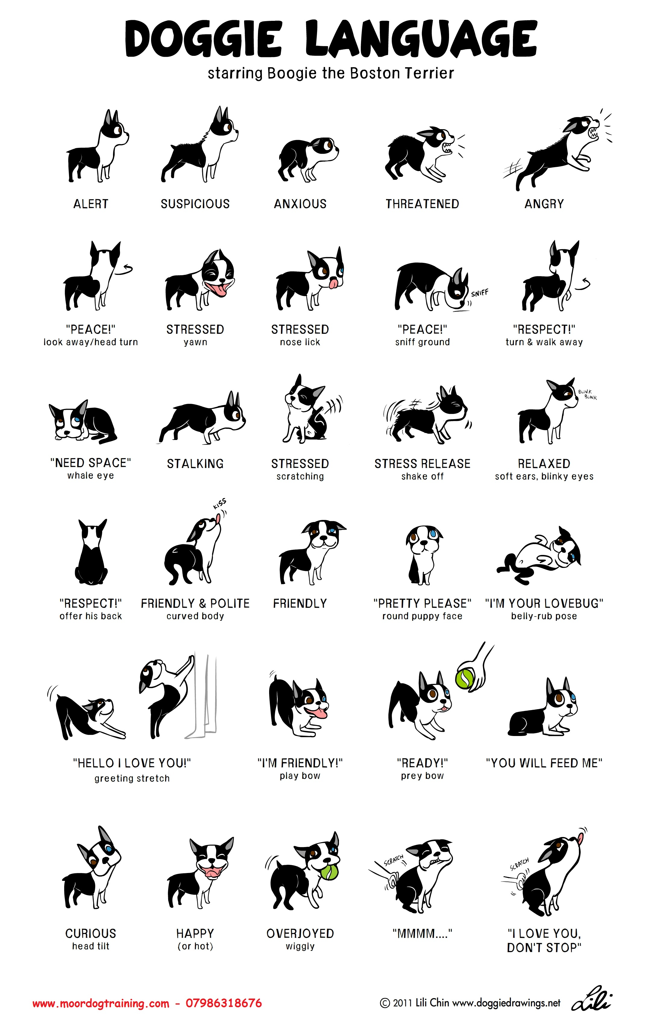
www.moordogtraining.co.uk

